Name__________________________________________________________ Date_______________________

Archaeologists unearth 4,000-year-old stone board game in Middle East country of Oman

By The Smithsonian Institution, adapted by Newsela staff
Published: 04/20/2022

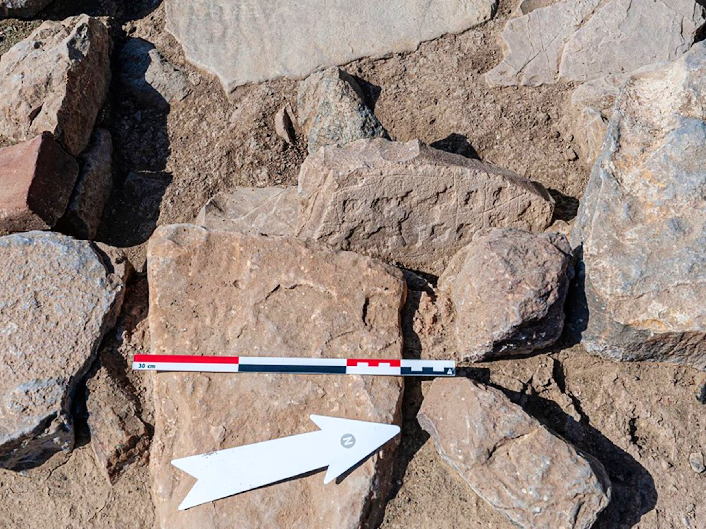

In December 2021, archaeologists were digging at a prehistoric settlement in the Qumayrah Valley, located in modern-day Oman. Prehistoric is the time before written history. The archaeologists discovered a stone slab carved with a grid and cup holes to hold game pieces.

It appears that even 4,000 years ago, our human ancestors passed time by playing their versions of board games.

The team of researchers was led by Piotr Bieliński of the Polish Centre of Mediterranean Archaeology and Sultan al-Bakri, Oman's director of antiquities. They found the large stone board in a structure near the village of Ayn Bani Saidah.

Similar Games Found In Many Places

Bieliński said that similar kinds of games have been found in "areas stretching from India, through Mesopotamia even to the eastern Mediterranean." Mesopotamia was an important region in the Middle East for early human civilization. He said one of the earliest-known game boards was found in the ancient Mesopotamian city of Ur's royal cemetery in 1922, dated around 4,500 years ago. Known today as the Royal Game of Ur, the two-player strategy game was similar to backgammon.

Board games have been played across the world for thousands of years. In Jerusalem, bored Roman soldiers were believed to have carved a grid for a board game on the steps of the Damascus Gate some 1,800 years ago, possibly an early form of modern-day checkers.

The stone board game in Oman was just one of several discoveries made at the excavation site. Archaeologists also unearthed the remains of stone towers — one of which is believed to have been 60 feet tall — and evidence of copper production. All dated to the Bronze Age, from 3200 to 1200 B.C.

"The settlement is exceptional for including at least four towers: three round ones and an angular one," says Agnieszka Pieńkowska of the Polish Centre, who is analyzing the site's artifacts and stone structures.

Site Was Known For Copper Trade

Researchers at Ayn Bani Saidah dated the settlement to the Umm an-Nar period, between 2600 and 2000 B.C.E. They discovered several copper items and smelting remains at the site, which suggests the site was involved in the early copper trade.

This shows that the settlement participated in the "copper trade for which Oman was famous at that time," said Bieliński. There were "mentions of Omani copper present in the cuneiform texts from Mesopotamia." Cuneiform was an early form of handwriting in the Arabian Peninsula.

The team also found evidence that the region remained an important trade and production site from 1100 to 600 B.C. That puts it through the second phase of the Iron Age.

The Qumayrah Valley has yielded many archaeological finds. It's likely because the area served as a major trade route between several Arab cities.

"This abundance of settlement traces proves that this valley was an important spot in Oman's prehistory," Bieliński said. "Ayn Bani Sadah is strategically located at a junction of [trade] routes."

The team plans to continue its excavations in 2022, focusing on areas surrounding the settlement and other parts of the Qumayrah Valley.

Questions:

- Using evidence from the text, explain why ongoing archeological digs are important.
- What does finding a game board at a prehistoric settlement tell you about that settlement?
- Using evidence from the text, explain what the discovery of stone towers at the Qumayrah Valley tell you about this ancient settlement?
- Choose an event, or idea from the text and summarize what you learned about it.

