Name_______________________________________________________ Date_______________________

When it comes to downing hot dogs, science says there’s a limit
By Jonathan Lambert, Science News for Students, adapted by Newsela staff
Published 08/19/2020

In the race to scarf down the most hot dogs in 10 minutes, competitive eaters may have a limit: 83 franks, buns and all.

That's the finding of a new analysis. It reviewed nearly 40 years of the storied Nathan's Famous Hot Dog Eating Contest. Nathan's hot dogs got their start in 1916 on the Coney Island boardwalk in New York City. A competition to see how many someone can eat started in the 1970s. Now that contest is a televised international event. The current record — 75 hot dogs — was set in July. It is vastly more than in the event's early days. Back then, champions downed a measly dozen or so franks.

James Smoliga is a physiologist at High Point University in North Carolina. He was watching the contest last year when an idea struck him. Could he apply the math equations used to estimate the limits of athletic performance to feats of gluttony?

Smoliga dug into the hot dog record books. He looked at records from 152 Nathan's competitors throughout 39 years. Based on that data, Smoliga calculated an upper limit of about 83 hot dogs in 10 minutes. That works out to about 832 grams per minute and more than 23,000 calories total. Smoliga reported his findings online July 15 in Biology Letters.

It's unclear if competitive eaters will ever reach that limit. But the scale of improvement "dwarfs other athletic achievements," Smoliga says. Record performances in sports like track and field have improved about 40 percent since record-keeping began. Meanwhile, hot dog-eating prowess has improved by 700 percent.

This graph shows the active consumption rates, measured in hot dogs swallowed per minute, of winners of the Nathan's Famous Hot Dog Eating Contest. Circles represent 10-minute competitions. Squares represent 12-minute competitions. The curve (black line) represents the change in rates over time. Physiologist James Smoliga projected a maximum rate of about 8.3 hot dogs per minute.

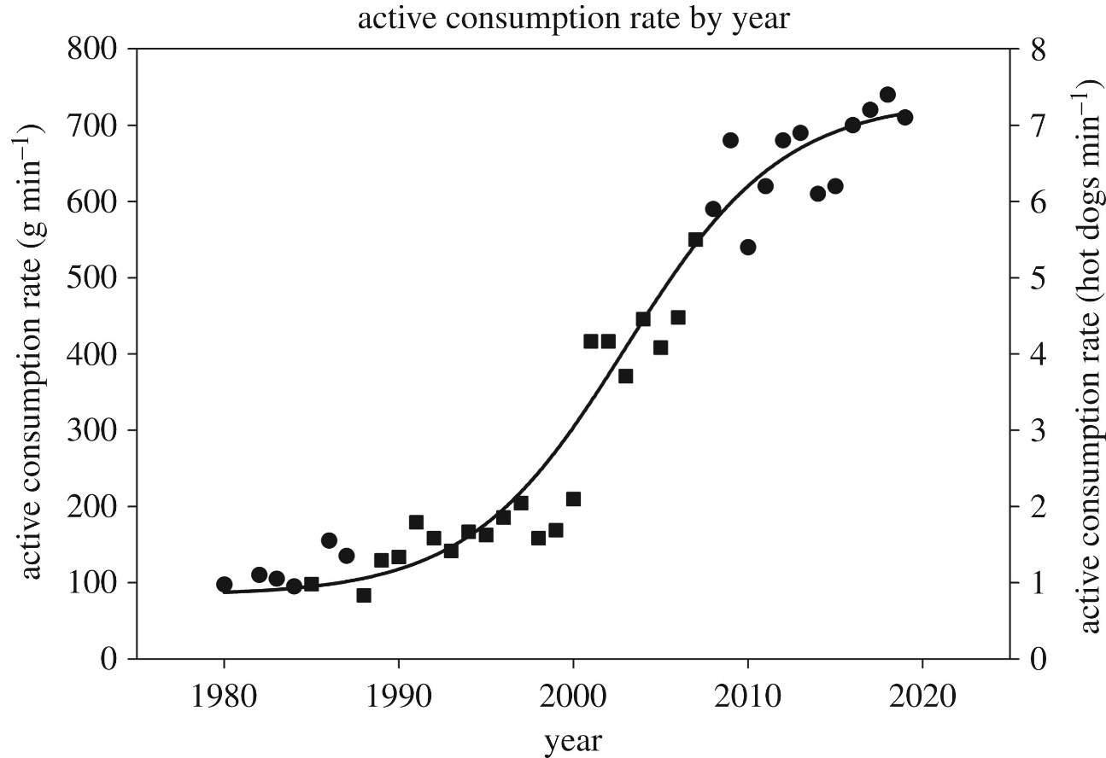

Active consumption rate (ACR) of the winner of the Nathan's Famous Hot Dog Eating Contest by year. Circles represent 10 minute competitions, squares represent 12 minute competitions. The spline represents predicted ACRs based on the nonlinear model. Image: Biology Letters

Humans even hold their own, pound for pound, against other meat-eating animals. Competitive eaters scarf food at a rate that bests that of grizzly bears and coyotes, Smoliga finds, although wolves lead the pack.

Quickly eating a lot of food can be useful for carnivores when food is scarce. That strategy may have proved useful in our evolutionary past, Smoliga says. Nowadays, inhaling six or seven hot dogs a minute for 10 minutes mostly leads to digestive problems. But if you're lucky, it could win you the coveted Mustard Belt of champions.

- Summarize this article in 5 or 6 complete sentences:

- What does the author want you to know? Create a bullet point list:

