Accessing the Nebo School District E-book Library with Sora:

Step 1 - Choose your method:

- Use the Sora app, or use an Internet Browser (Chrome, Internet Explorer, etc.)
- The Sora App is free to download from the Apple App Store or the Google Play Store
- If you are using a device that doesn't have the Apple App Store or the Google Play Store, you can access Sora in an interne browser at soraapp.com

Step 2 - Find Nebo School District's collection:

- Click - I have a setup code at the bottom center of the screen.
- Nebo setup code is nebout. Enter it in the available line.
- Click the green "Get started" button.

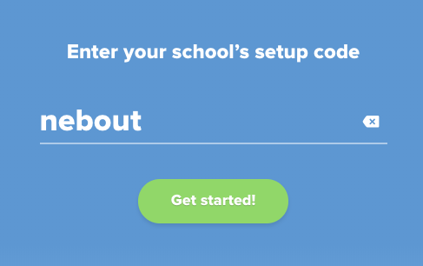

Step 3 - Select the correct option from the dropdown menu:
- Click the dropdown
  - If you're a student, select "Nebo School District Students".
  - If you're a teacher/staff, select "Nebo School District Staff".

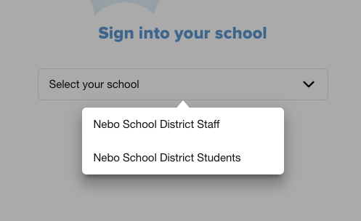

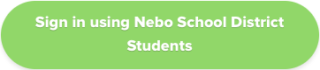
- Click the green Sign In button

Step 4 - Sign in with your school Google email and password (personal Google accounts will not work).

