Name___________________________________________________________ Date__________________

New NASA rover lands on Mars with a helicopter
By Newsela staff
Published: 02/18/2021

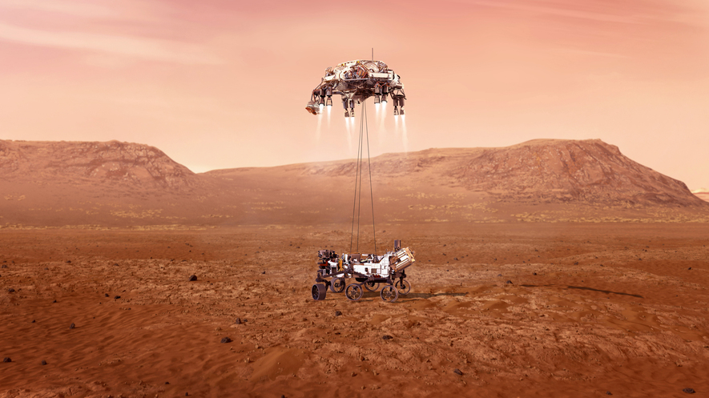

NASA's new rover, Perseverance, arrived on Mars on February 18, 2021 after traveling more than 470 million kilometers (300 million miles) over the course of seven months. The six-wheeled robot landed near the planet's equator in a crater 45 kilometers wide (28 miles).

Mars has the nickname the red planet because it's covered in a red, rusty dust. The purpose of the two-year mission is to collect data about microbial life that could have existed there billions of years ago, in places like the crater. Microbes are very small living things, such as bacteria.

Learning more about the composition of Mars can help scientists better understand the planet's history and help lay the groundwork for future human missions to the neighboring planet.
High-Tech Data Collector
Perseverance is about the size of a car and designed to move on its own. It has two computers which it uses to navigate—one computer figures out where the rover needs to go and the other computer "sees" its surroundings.

Traveling around the red planet will help the high-tech robot achieve its other goal, which is to gather scientific data with several high-tech instruments. For example, there are instruments used to take photos, map the surface of Mars and determine what kinds of chemicals and minerals there are. Other tools will collect soil samples and store them until they are returned to Earth.

Perhaps the most interesting new instrument on board is the 1.8 kilograms (4 pound) helicopter named Ingenuity. The helicopter's short solar-powered flights will help scientists observe Mars from a different perspective and provide more information about how humans and other robots might fly there in the future.

The helicopter works a little differently than on Earth, as the atmosphere on Mars is about 99 percent less dense than the atmosphere on Earth. Density measures how tightly packed particles are, and an atmosphere is a layer of gases that surrounds a planet. Because the atmospheric gases are less dense on Mars, the helicopter might have a more difficult time achieving lift, which is a mechanical force that holds an aircraft in the air by directly opposing its weight.

Years in the Making
Using technology to explore Mars goes back more than 50 years. Engineering a landing on Mars is hard, and only about 40 percent of missions sent to Mars have been successful, according to NASA.

The first two NASA spacecrafts to land on Mars were Viking 1 and 2 in 1976. Later, scientists began using moving robots called rovers. Perseverance is the fifth rover to land on the red planet, joining four other six-wheeled bots named Sojourner, Spirit, Opportunity, and Curiosity respectively.

Humans on Mars?
So far, the only human presence on Mars has been through the robots we've sent there. But this could change during your lifetime, as space agencies like NASA and private companies are working to make this a reality. The hope is that the Perseverance mission, along with others, will help achieve this goal.
Interested in learning more about the new helicopter? Watch this video from NASA to learn more about how it works.

- Using evidence from this text, explain why NASA sent the Perseverance to Mars and what they hope to achieve through this space mission.

- Using evidence from this text, explain how the helicopter Ingenuity will affect Perseverance's mission.

- Why do you think people are so fascinated with the planet Mars and want to go there?

