Name________________________________________________________ Date_______________________________

National Anthem and Flag Etiquette
Constitution Daily

In the United States legal code, there are statutes that apply to flag etiquette, the Pledge of Allegiance, and the National Anthem. Currently, these statutes don’t include language that would make it a criminal offense to disobey the guidelines, but the rules are widely followed.
That hasn’t always been so. In 1968, Congress approved the Federal Flag Desecration Law after a Vietnam War protest. The law made it illegal to “knowingly” cast “contempt” upon “any flag of the United States by publicly mutilating, defacing, defiling, burning or trampling upon it.” But in 1989, a deeply divided United States Supreme Court upheld the rights of protesters to burn the American flag in a landmark First Amendment decision.
A second Supreme Court decision in 1990 struck down a new federal law that made it a criminal offense to burn American flags in protest. “If there is a bedrock principle underlying the First Amendment, it is that the Government may not prohibit the expression of an idea simply because society finds the idea itself offensive or disagreeable,” said Justice William Brennan at the time.
The National Anthem statute now on the books, known as 36 U.S. Code § 301, acknowledges that the Star-Spangled Banner is the official national anthem; and that military members should salute as it plays or is performed, while “all other persons present should face the flag and stand at attention with their right hand over the heart, and men not in uniform, if applicable, should remove their headdress with their right hand and hold it at the left shoulder, the hand being over the heart.” In all cases, the attention given to the anthem should be the same, regardless of the presence of the flag at the location.
These rules and customs are similar to those followed for the Pledge of Allegiance. In 1943, the Supreme Court invalidated a West Virginia state law that required members of the Jehovah’s Witnesses group to salute the flag and recite the Pledge. “If there is any fixed star in our constitutional constellation, it is that no official, high or petty, can prescribe what shall be orthodox in politics, nationalism, religion, or other matters of opinion, or force citizens to confess by word or act their faith therein,” said Justice Robert Jackson.

4 U.S. Code § 8.Respect for flag
U.S. Code

No disrespect should be shown to the flag of the United States of America; the flag should not be dipped to any person or thing. Regimental colors, State flags, and organization or institutional flags are to be dipped as a mark of honor.

(a) The flag should never be displayed with the union down, except as a signal of dire distress in instances of extreme danger to life or property.

(b) The flag should never touch anything beneath it, such as the ground, the floor, water, or merchandise.

(c) The flag should never be carried flat or horizontally, but always aloft and free.

(d) The flag should never be used as wearing apparel, bedding, or drapery. It should never be festooned, drawn back, nor up, in folds, but always allowed to fall free. Bunting of blue, white, and red, always arranged with the blue above, the white in the middle, and the red below, should be used for covering a speaker’s desk, draping the front of the platform, and for decoration in general.

(e) The flag should never be fastened, displayed, used, or stored in such a manner as to permit it to be easily torn, soiled, or damaged in any way.

(f) The flag should never be used as a covering for a ceiling.

(g) The flag should never have placed upon it, nor on any part of it, nor attached to it any mark, insignia, letter, word, figure, design, picture, or drawing of any nature.

(h) The flag should never be used as a receptacle for receiving, holding, carrying, or delivering anything.

(i) The flag should never be used for advertising purposes in any manner whatsoever. It should not be embroidered on such articles as cushions or handkerchiefs and the like, printed or otherwise impressed on paper napkins or boxes or anything that is designed for temporary use and discard. Advertising signs should not be fastened to a staff or halyard from which the flag is flown.

(j) No part of the flag should ever be used as a costume or athletic uniform. However, a flag patch may be affixed to the uniform of military personnel, firemen, policemen, and members of patriotic organizations. The flag represents a living country and is itself considered a living thing. Therefore, the lapel flag pin being a replica, should be worn on the left lapel near the heart.

(k) The flag, when it is in such condition that it is no longer a fitting emblem for display, should be destroyed in a dignified way, preferably by burning.

Using information from the US Flag Code, federal law, and US Supreme Court decisions regarding the American flag, evaluate the following images. Explain what is right or wrong with the use of the flag. Is the use legal or illegal and if illegal, is it a punishable offense? Use evidence from the Flag Code, as well as federal law to support your evaluations.

How does the US Supreme Court clarify the US Flag Code?

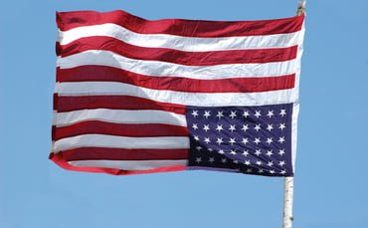
Image 1 Image 2

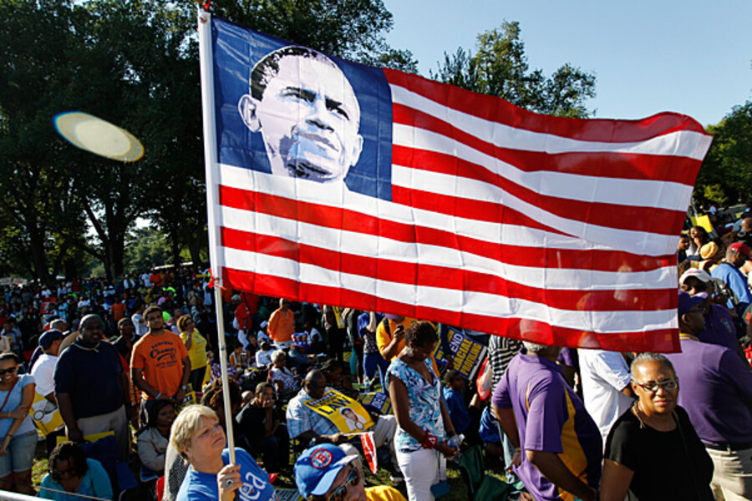
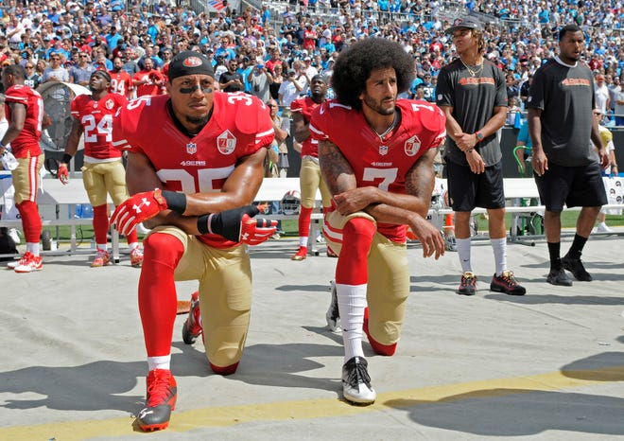
Image 3 Image 4

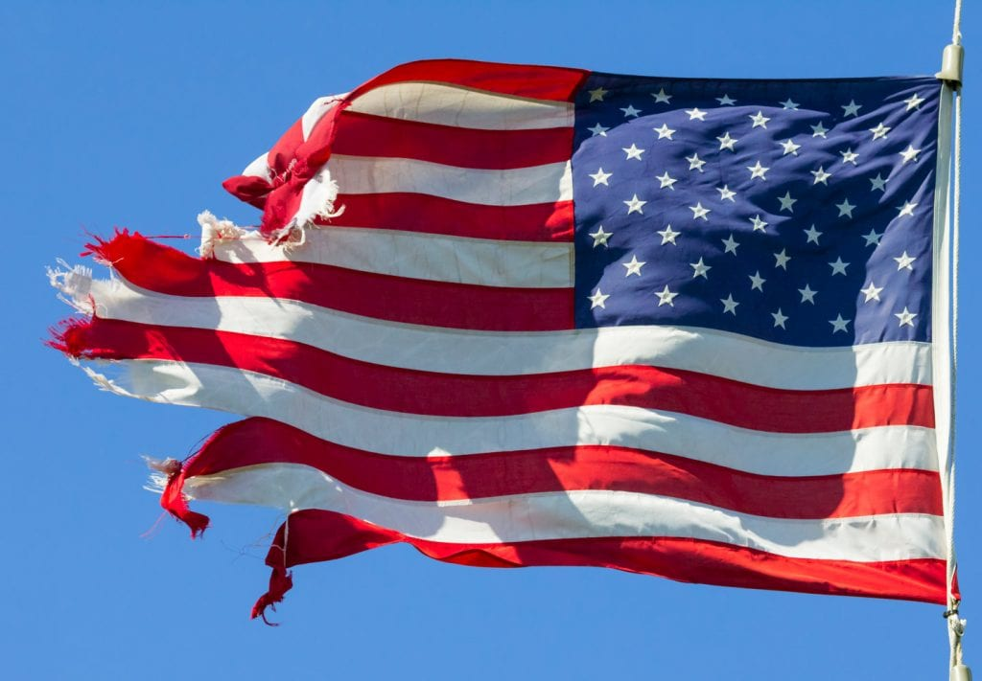
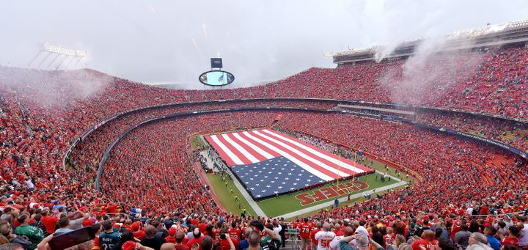
Image 5 Image 6

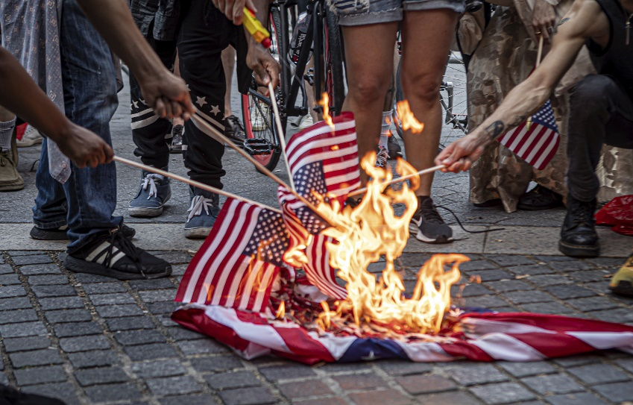
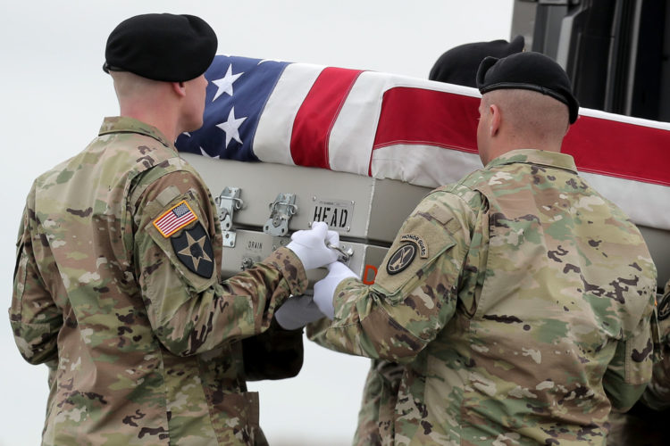
Image 7 Image 8
Image 9 Image 10
